
RoboWild
Non-Profit Organisation


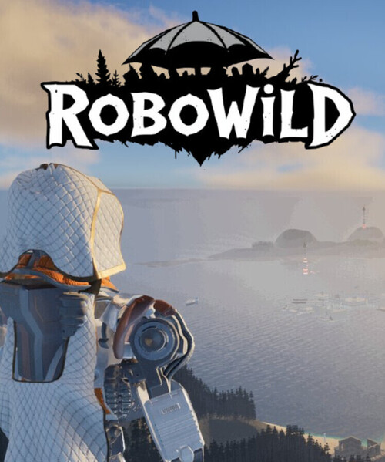
Prepared by:
Cleopatra Tayeta
Gmail: ST10533635@RCCONNECT.EDU.ZA
Contact No: 0788144980

Prepared For:
Casey Jensen Gmail: casey@fabrikam.com Contact No:573-555-0172
Fabrikam, Inc. www.fabrikam.com
Address: 333 3rd Avenue Seattle, WA 89101
Avery Howard Gmail: avery@contoso.com Contact No:898-555-0111
Contoso, Ltd. www.contoso.com
Address: 987 6th Ave Santa Fe, NM 11121

Name &Surname: Cleopatra Tayeta
Student No: ST10533635
MODULE CODE: WEDE5020
MODULE NAME: Web Development

TABLE OF CONTENTS

1. Organisation Overview 2
2. Website Goals and Objectives 2
3. Current Website Analysis 3
4. Proposed Website Features and Functionality 3
5. Design and User Experience 3
4
6. Technical Requirements 4
7. Timeline and Milestones 4
8. Budget 5
References: 5

Proposal 1: RoboWild: Global Alliance for IT & Robotics in Animal Innovation
Organisation type: Non-Profit Organisation

1. Organisation Overview
Name: RoboWild: Global Alliance for IT & Robotics in Animal Innovation
Brief History: RoboWild is a non-profit organisation that uses information technology and robotics to support wildlife conservation. It brings together IT professionals, engineers, conservationists and volunteers to develop practical technology that helps monitor and protect wildlife. The organisation aims to encourage collaboration between the technology sector and conservation organisations while promoting sustainable solutions for protecting endangered animals.

•Mission: To advance animal welfare and conservation by making robotics, AI and IT innovation accessible to the organisations that protect wildlife.

•Vision: A world in which every conservation and animal-welfare organisation has the technology and technical skills needed to protect the species in its care.

•Target audience: Robotics/IT professionals and students seeking volunteering opportunities; wildlife and conservation NGOs needing technical support; individual donors and corporate sponsors; and members of the public interested in conservation-technology stories.

2. Website Goals and Objectives
- Raise global awareness of RoboWild's mission and recruit volunteer technologists and researchers
- Showcase active and completed projects (e.g. tracking drones, anti-poaching sensors, animal-monitoring dashboards) to attract partners and funding.
- Provide a simple enquiry channel for NGOs seeking technical support and for volunteers wanting to join.
Key Performance Indicators (KPIs):
- Number of volunteers that register through the website.
- Growth in newsletter/social media referral traffic to the site.
- Number of partnership enquiries received from conservation organisations.

3. Current Website Analysis
RoboWild does not yet have an existing website. This project therefore establishes its first digital presence rather than redesigning one; the proposal instead sets a benchmark for accessibility, clarity, and credibility that future iterations can be measured against.

4. Proposed Website Features and Functionality

•Homepage (index.html): hero banner, mission statement, project highlights and a clear call-to-action.

•About Us (about.html): organisation history, mission, vision and team introduction.

•Our Projects (projects.html): detailed information about current and completed initiatives.

•Get Involved / Enquiry (enquiry.html): separate forms allowing visitors to enquire about volunteering or sponsorship.

•Contact (contact.html): contact details, an embedded map showing more than one location, and a contact form. A responsive navigation menu that functions correctly across every page of the site.

  - SITEMAP
Figure 1 Prosed sitemap showing the relationship between RoboWild core pages.

5. Design and User Experience
- Colour Scheme: Forest green and deep ocean blue to evoke land and marine conservation, paired with an amber accent for calls-to-action.
- Typography: A clean sans-serif (e.g. Aptos/Open Sans) for readability across technical and non-technical audiences; bold headings for visibility.
- Layout and Design: Grid-based, content-first layout with generous white space, prioritising credibility and clarity over decoration.
User Experience Considerations:
- Simple, accessible navigation so non-technical conservation partners can find information easily.
- Mobile-responsive layout, since many field conservationists will access the site on tablets/phones.
- Clear visual hierarchy separating 'volunteer' and 'partner' calls-to-action.

RoboWild Proposed Colour Palette

Forest Green Deep Ocean Blue Amber Accent Soft Grey [BG] Charcoal Text
Figure 2colour palette for RoboWild: Global Alliance for IT & Robotics in Animal Innovation.

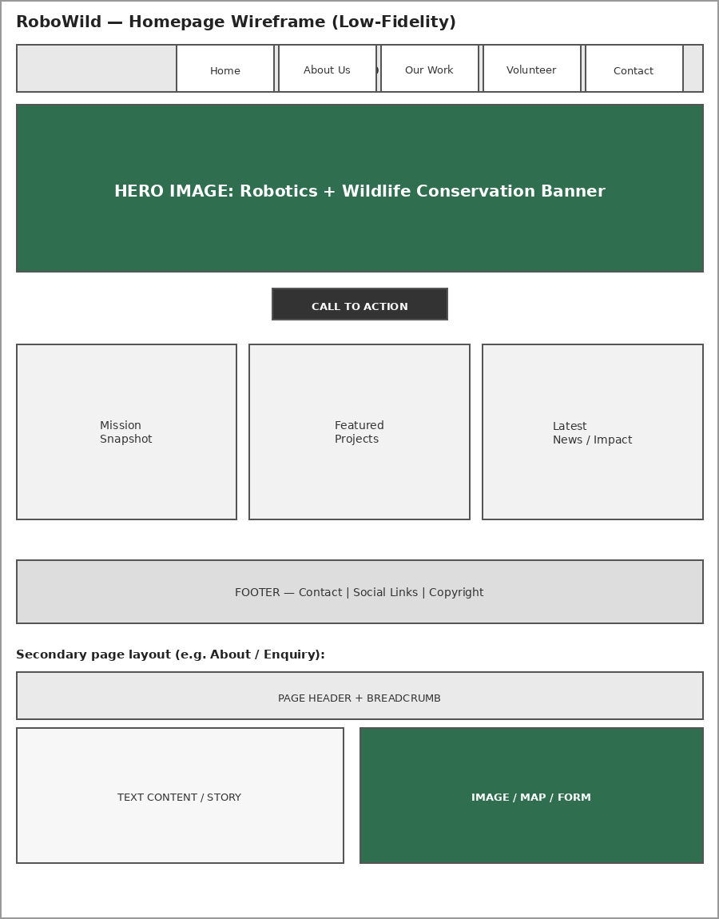

6. Technical Requirements
- Hosting: shared or NPO-discounted hosting.
- Domain: robowild.org.
- Languages/Frameworks: HTML5, CSS3, and JavaScript for Part 1–3 of this module; static-site approach with no server-side dependency required at this stage.

7. Timeline and Milestones
Weeks | Milestone | Deliverable
Week 1 | Approval of proposal & content research | Approved proposal, gathered content/images
Week 2 | Sitemap & file/folder structure finalised | Sitemap diagram, folder structure
Week 3 | HTML structure for all 5 pages built | Initial HTML files pushed to GitHub
Week 4 | Navigation linked & content integrated | Fully linked, content-complete site
Week 5 | Testing, debugging & README finalised | Final Part 1 submission

8. Budget
Items | Description | Estimated cost (ZAR)
Domain registration | Annual.org domain registration | R250 - R350
Hosting | Static hosting (NPO-tier/ free tier GitHub Pages) | R0 – R1000
Design assets | Icons, stocks imagery licences (public domain preferred) | R0 -R500
Maintenance | Ongoing volunteer-led updates) est.per year | R800
Total (Year1 estimated) |  | R750 -R16500

References:
· iStock. (n.d.). Low-fidelity wireframe templates for web design. Available at: https://www.istockphoto.com/ [Accessed: 03 August 2026].
· W3Schools. (2026). HTML Forms and Input Elements. Available at: https://www.w3schools.com/html/html_forms.asp [Accessed: 02 August 2026].

